**Setting Up the Environment.**

1. **Step:- Download/Install GNS3 GUI.**
   1. Goto<https://www.gns3.com/software> and download the latest GNS3 GUI V 2.2.10 and

Install.

1. Step: Download GNS3 VM 2.2.10 and import into vmware(Recommended).
2. Go to [https://www.gns3.com/software/download-vm download the GNS3](https://www.gns3.com/software/download-vm%20download%20the%20GNS3) vm for ‘VMware Workstation and Fusion’.
   1. Note:- Make sure the GNS3 GUI and VM Version Matches.
   2. Note:- Don’t make any configuration changes for VM. (e.g:- RAM.CPU)
3. Step :- Download GNS3 Network Automation appliance.

Go to <https://www.gns3.com/marketplace/appliance/network-automation> or goolgle “ansible network automation in gns3” and download. Click and download. You will get one file in .gns3a extension

1. Step :- Import networkAutomation appliance.

Click edit and Import appliance 🡪 Select the download file (Use all recommended/default options while importing.) It will take some time for importing and downloading.

Once its download you can see success message in the console and you can see that appliance is ready to use.

1. Step:- Import network devices(Router).

* Click on ‘new templates’ in side routers logon on the left-hand side:- (As shown)

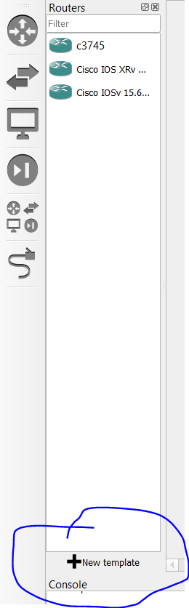

* Click on next keeping all recommended settings.
* Click on routers inside it choose IOSv and click install 🡪 next 🡪
* Click on IOSv version 15.5(2) T and upload the image that you have downloaded from drop box and 🡪 next.
* Should see the appliance in GNS3 routers Section.

1. Step:- Import network devices(Switch).

* Click on ‘new templates’ in side Switch logon on the left-hand side:- (As shown)

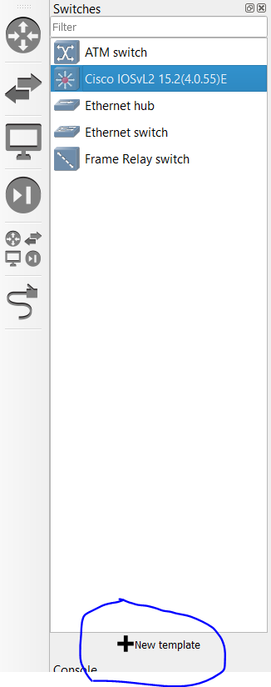

* Click on next keeping all recommended settings.
* Click on Switch inside it choose Cisco IOSvL2 and click install 🡪 next 🡪
* Click on IOSv version 15.5(4.0.55)E and upload the image that you have downloaded from drop box and 🡪 next.
* Should see the appliance in GNS3 Switch Section.